Interstate Mercury Education & Reduction Clearinghouse
APPLICATION FOR EXEMPTION TO
MERCURY-ADDED PRODUCT PHASE-OUT
For IMERC use only

Date received:

Date of Submission:

IMPORTANT NOTES:
- Please type or complete using black ink.
- All applications must be submitted online through the e-filing system — NO fax or email submissions will be accepted. Applications for phase-out exemptions in Rhode Island must be notarize and submitted in hard copy. See Page 9 for instructions on how to submit online and to Rhode Island.

An up-to-date listing of mercury-added products that are banned in IMERC-states, information about whether these states allow for an exemption process, and statutory exemptions that may apply, is available at www.newmoa.org/prevention/mercury/imerc/banphaseout.cfm.

Automobile Switches | Button-Cell Batteries | Dairy Manometers
Diostats | Fever Thermometers | Lamps
Measuring Devices | Pressure Transducers | Switches and Relays
Thermometers | Thermostats | Other (see website)

Using the check boxes below, please indicate the IMERC-member states you wish to review the exemption application. Only the states checked below will review the application. Before completing this section, please verify whether your product(s) is eligible for a phase-out exemption in certain state(s).
Connecticut | Louisiana | Maine¹
Massachusetts | Minnesota² | New Hampshire
New York | Rhode Island³ | Vermont
Please contact the IMERC Coordinator, at (617) 367-8558 or imerc@newmoa.org, if you have questions about the product category or which states an exemption application is applicable.
¹ Contact Maine directly to file an application for an “advanced technology product.” See www.maine.gov/dep/mercury/hgrequire.html for definition and more information.
² See Minnesota Statute 116.92, Subd. 8e for conditions to receive an exemption for switches and relays only, in conjunction with IMERC. They do not use this form – applicants must submit a letter to the Commissioner following decisions from other states.
³ Rhode Island must receive a notarized hard copy of the application (see Page 9 for mailing instructions) and a $200 application fee.
I. Type of Application:

New Application
Renewal Application
Update to Previous Application

II. Applicant's Full Legal Name, Address, & Contact Information:

Name/Organization:
Mailing Address:
City/Town: State:
Zip Code: Telephone #:
Website:

Contact Person: Telephone #:
Mailing Address:
City/Town: State:
Zip Code: E-mail address:

Please check one of the boxes below to indicate your relationship to the product manufacturer:
Product Manufacturer Importer Distributor
Product User Representative of Product Manufacturer

III. Product Manufacturers’ Name, Address, & Contact Information
(if different from above)

Name/Organization:
Mailing Address:
City/Town: State:
Zip Code: Telephone #:
Website:

Contact Person: Telephone #:
Mailing Address:
City/Town: State:
Zip Code: E-mail address:

IV. Product Information

Describe the mercury-added product or product component for which you seek an exemption and the uses of the product:

Briefly describe the purpose of and need for the mercury in the product:

V. Mercury-added Replacement Parts

Are you seeking this exemption for the sole purpose of allowing the sale of replacement parts in a larger product?
Yes No

If no, proceed to Section VI. If yes, please answer the following additional questions before proceeding to Section VI.
- When was the larger product placed in service?
Before July 1, 2006
 On or after July 1, 2006 but before January 1, 2007
On or after January 1, 2007 but before July 1, 2007
 On or after July 1, 2007

- If the replacement part is a switch or relay is the switch or relay integrated and not physically separate from other components of the larger product?
Yes No

- Is the larger product used in manufacturing?
Yes No
If yes, describe the function of the larger product in the manufacturing process:

VI. Basis for Mercury-added Product Exemption Request

Indicate the basis for your exemption application by checking the appropriate line below.
- There are no technically feasible non-mercury alternatives available.

- There are technically feasible non-mercury alternatives available but the costs to users are too costly compared to the cost of the mercury-added product.

- The use of mercury in the product is mandated by a state or federal law or other requirement (e.g., industry standard such as ASTM, federal contract specification).

- The use of the mercury-added product provides a net benefit to the environment, public health or public safety when compared to non-mercury alternatives.

VII. Required Supporting Information

The following information must be submitted with your Application:

1. An IMERC Mercury-added Product Notification Form approval letter for the most recent triennial filing period (i.e., 2004, 2007, 2010, 2013).

2. If you checked Section VI (1) or (2) as the basis for your exemption request, attach a narrative and supporting data that, at a minimum:
- Describes why the product or component must use mercury;
- Describes in detail the potential non-mercury alternative products or components and why they are not technically feasible (e.g., electrical performance, size, power consumption, product life);
- Describes the current status of the industry efforts to find a non-mercury substitution;
- Describes the process by which you researched available non-mercury alternative products or components and made a determination that they are not feasible, including discussions with outside unbiased experts;
- Includes data documenting a claim that costs are unreasonable if there are technically feasible non-mercury alternatives. Please include an analysis of life cycle costs to specific product uses covering all associated costs including spill cleanup and hazardous waste disposal costs during the last 5 years immediately proceeding the filing of the exemption application; list specific uses of the product for which exemption is requested and the price or range of prices at which the product is sold to users; list prices by non mercury alternative for each use; and provide an explanation of additional costs to replace mercury with non mercury alternative and how these additional costs are determined;
- Identifies the risks to human health associated with the use of mercury in the product and pathways by which humans could be exposed to the mercury. Include the likelihood that mercury in the product will be released to the environment or that users of the product will be exposed to mercury.

- If you checked Section VI (3) as the basis of your exemption request, provide a citation to the federal or state law or other requirement (e.g., industry standard such as ASTM, federal contract specification):

Also provide a copy of the law or other requirement and highlight the specific provision that requires the use of mercury. If the law cites an industry standard please provide a copy of the industry standard to document the required use of mercury.

4. If you checked Section VI (4) as the basis of your exemption request, attach a narrative and supporting data that:
- Specifies all uses of the product for which you are seeking an exemption and explicitly describes each benefit to the environment and public health and safety that you are claiming for that use;
- Explains how the claimed benefit differs from the benefits afforded by available non-mercury alternatives to the mercury-added product;
- Estimates the amount of mercury that will be placed in commerce annually if the exemption is granted;
- Explains the likelihood that mercury in the product will be released to the environment or that users of the product will be exposed to the mercury;
- Identifies the risks to human health associated with the use of mercury in the product and the pathways by which humans could be exposed to the mercury; and
- Lists the steps, if any, that will be taken, through product design or otherwise, to ensure that the mercury in the product is not released during use and disposal.

VIII. Collection Plan

If you meet the criteria for the states’ product phase-out exemptions as outlined above in Sections VI and VII, you also need to include a description of the proposed or existing system for ensuring that the mercury-added product will be properly collected, transported, and processed when the user is done with it. Attach a narrative and supporting data that, at a minimum:
- Describes how the system will work and who will run it;
- Includes an estimate of the number of units of the product expected to be available for collection each year and the number of these units or percentage that the collection system can reasonably be expected to capture;
- Includes the performance measures to be used to demonstrate that the collection system is meeting the capture rate target and steps that will be taken to improve the collection system if the expected capture rate is not achieved;
- Describes a public education program, including implementation dates, which will inform the relevant portions of the public and private sector about the mercury-added products, the purpose of the collection system program, how they may participate, available collection opportunities, and legal requirements for management of the product;
- Proposes the frequency and method for disposal/recycling of the items that are collected, including removal and proper management;
- Demonstrates the financing for the implementation of the proposed collection system and whether there are any user fees;
- Describes the recordkeeping protocol that the manufacturer or company other than the manufacturer will maintain to assure compliance with this Plan; and
- Includes documentation of the readiness of all necessary parties to perform as intended in the collection and recycling or disposal system.

IX. Renewal Application

If you are requesting the renewal of an exemption previously granted by one or more IMERC-member states, please attach a detailed narrative describing your efforts to eliminate the use of mercury in the product or replace the product with one that does not require the use of mercury.

X. Certification

As the applicant for this exemption, I have personally examined and am familiar with the information submitted in this document and all attachments thereto, and I certify that based on reasonable investigation, including my inquiry of the individuals responsible for obtaining the information, the submitted information is true, accurate, and complete to the best of my knowledge and belief. I certify that this application is on a complete and accurate Form as prescribed by the member states of the Interstate Mercury Education Reduction Clearinghouse Committee (IMERC) without alteration of text. I understand that a false statement in the submitted information may be punishable as a criminal offense, in accordance with the applicable IMERC members’ state laws.

Signature (of an Authorized Senior Management Official or designee) Date

Print or Type Name and Title of the Authorized Senior Management Official, or designee

For Applicants to Rhode Island:

Notary Signature Commission Expires

XI. MANUFACTURER’S Designated Industrial Trade Group Registration

Manufacturers electing to designate an industrial trade group to submit their Application for Exemption to Mercury-added Product Phase-Out on their behalf must include a completed and certified Registration that demonstrates that the trade group is designated by the manufacturers to submit the required information. The trade organization must compile all of these Forms and submit them with their Application for Exemption to Mercury-added Product Phase-Out. Trade Groups should undertake the following steps to complete this process:

1. Ask each manufacturer for whom you are submitting information to complete and certify this Section. Make and attach additional copies of this Section as needed. Only applications with original signatures will be accepted by the participating IMERC states. No faxes, electronic submissions, or applications with copied signatures will be accepted. All information must be either typed or legibly printed using black ink.

- Complete and return the original Manufacturer’s Designated Industrial Trade Group Registrations with the full Application for Exemption to Mercury-added Product Phase-Out.

Manufacturer’s Name:
Mailing Address:
Street Address (if different from mailing address):
City/Town: State:
Zip Code: Telephone #:
Manufacturer’s Web Address:

Contact Person’s Name:
Contact Person’s Title:

Contact Person’s Mailing Address:
Street Address (if different from mailing address):
City/Town: State: Zip Code:
Contact Person’s Telephone #:
Contact Person’s E-mail address:

Designated Industrial Trade Group:
Industrial Trade Group Name:

Manufacturer's Certification of Designated Industrial Trade Group Registration:

I have personally examined and am familiar with the information submitted in this document and all attachments thereto on behalf of my company, and I certify that based on reasonable investigation, including my inquiry of the individuals responsible for obtaining the information, the submitted information is true, accurate, and complete to the best of my knowledge and belief. I certify that this Application is on a complete and accurate Form without alteration of text. I understand that a false statement in the submitted information may be punishable as a criminal offense, in accordance with the applicable IMERC members’ state laws.

Signature (of an Authorized Senior Management Official or Designee) Date

Print or Type Name & Title of the Authorized Senior Management Official, or Designee

For applicants to Rhode Island:

Notary Signature Commission Expires
INSTRUCTIONS

If applying for an exemption in Rhode Island, complete and submit an original, notarized copy to the following addresses with payment of a $200 fee:

Attn: Ann Battersby
Rhode Island Department of Environmental Management
235 Promenade St. OTCA
Providence, RI 02908
(Include $200 fee with the notarized application to RI DEM)

Note: the hard-copy submission to RI DEM is only required if you are applying for an exemption in that state. If not, you only need to submit the application online to IMERC.

Complete and submit an electronic copy of this application by following the instructions below.

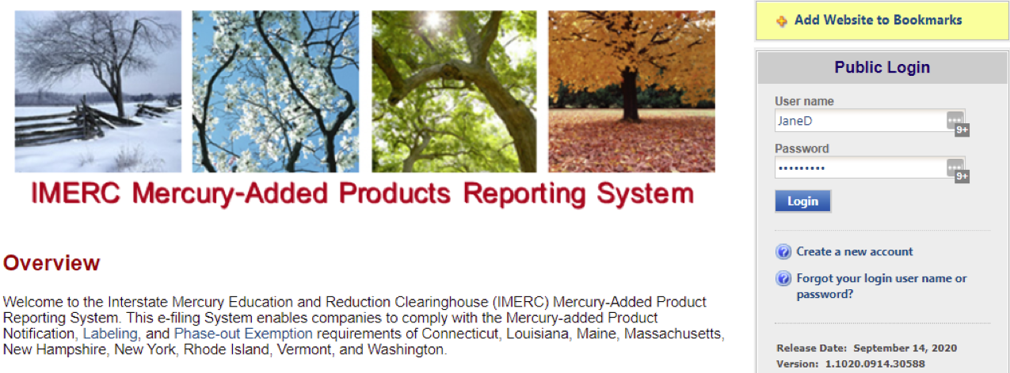

Log in to your GovOnline account. Click on the link for Phase-out Exemption in the Notification Renewal Quick Access panel on the left side of the dashboard.

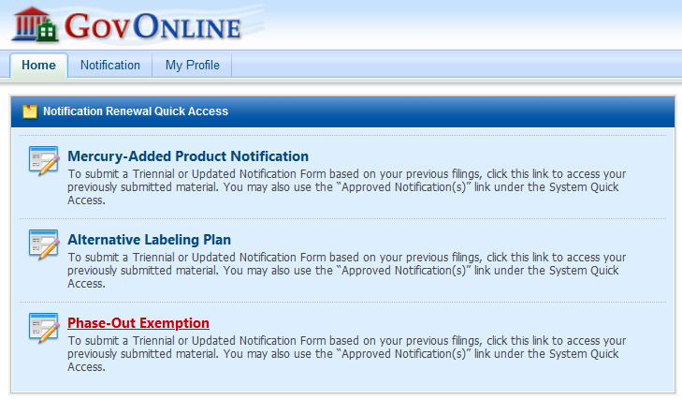

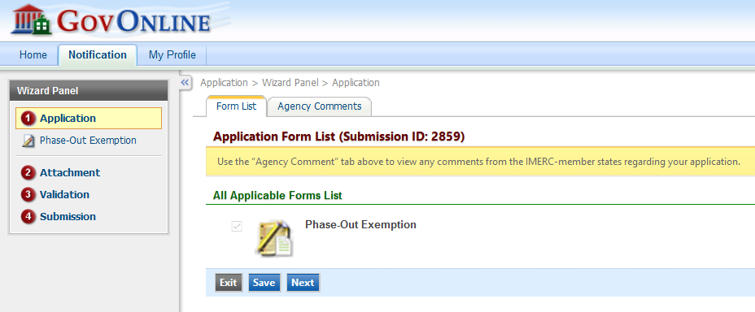

Click Next on the Application Form List. On the following screen, select the company you are making the submission for to and which state you are applying for an exemption from product phase-out provisions. Click Next. Note: you should repeat this process and make individual submissions to each state as states individually review and make decisions on applications for exemptions.

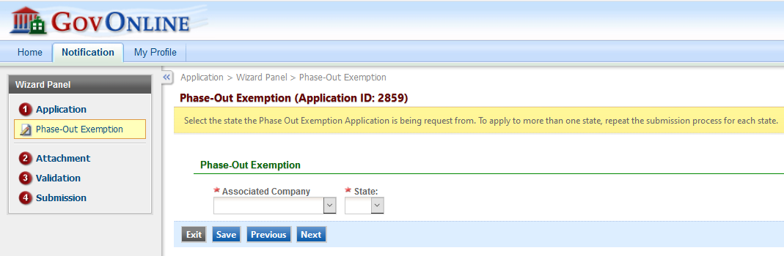

Upload the Phase-Out Exemption Application (above) that you have already filled out and saved in either Microsoft Word or Adobe Acrobat by clicking on the red “Add File(s)” button.

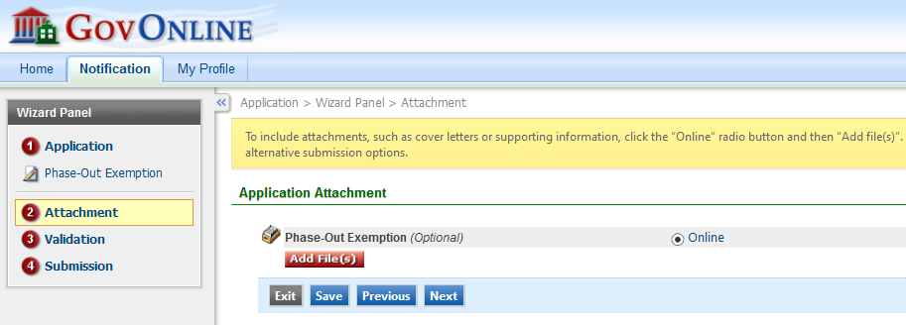

Browse to the location you saved the file.
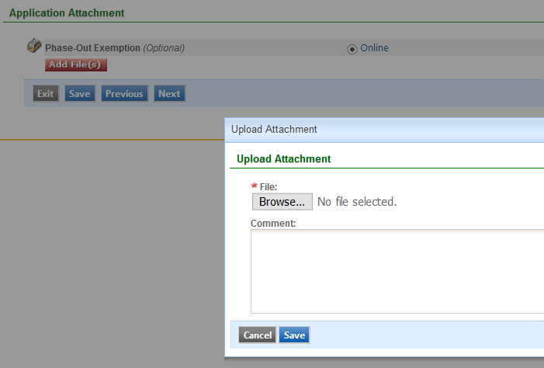

Select the file, click Open and then Save.

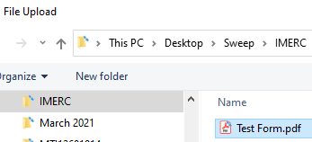

You will receive an on-screen confirmation that the upload suceeded. Then click Next.
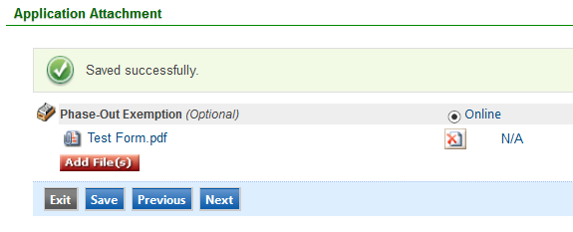

Follow the on-screen instructions to review and validate your submission before proceeding to the Certification page.

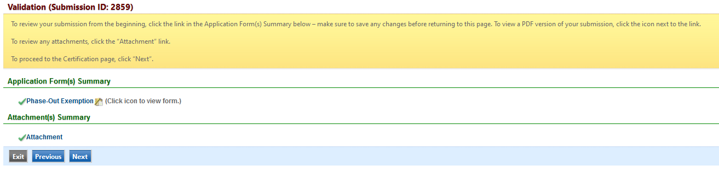

Check the box to certify your submission and then answer a security question that you responded to when creating your account. Once completed, review the Disclaimer before clicking Submit.

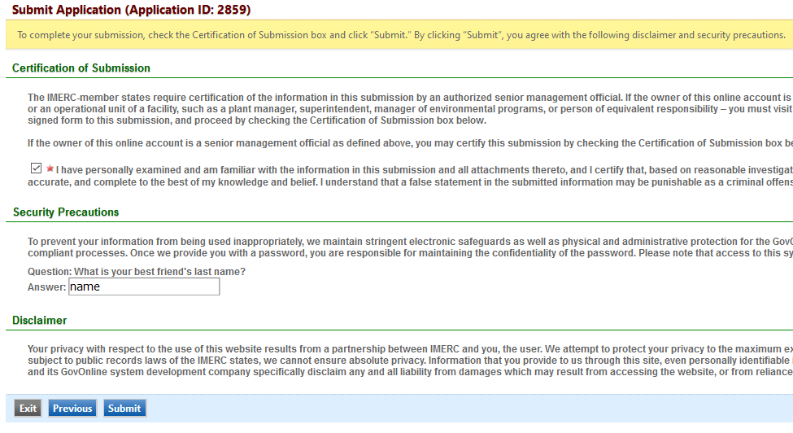

You will receive an email confirmation of your submission. Upon their review, the relevant state agencies will contact you regarding the status of your applications.

